American University of Beirut
Department of Electrical and Computer Engineering
EECE 310 – Electronics Fall 2011 – 2012

Due Wednesday January 11, 2012 at 9:00 am

Homework 10

1. [20 points] Consider the BJT circuit shown in Figure 1.

a) Find the minimum value of the collector voltage [10 points], such that the BJT remains in the active region. Assume β = 150.

b) Find the value of R_{C} [10 points] needed to get a collector voltage half-way between the value calculated in part (a) and V_{CC} = +12V.

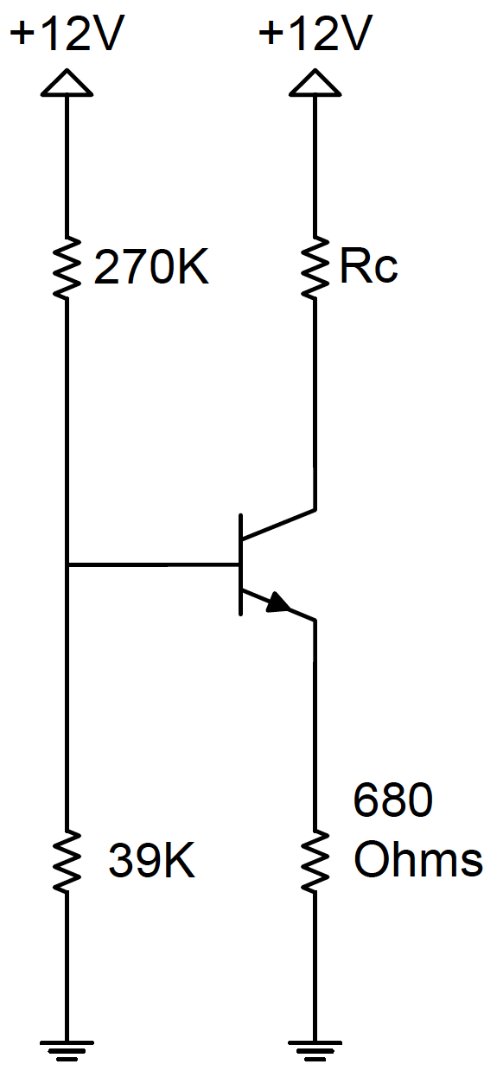
Figure 1

2. [80 points] For the circuit shown in Figure 2, the BJT has β = 160 and V_{A} = 80 V.
Assume that V_{T} = 26 mV and that all capacitors are very large.

a) Find the DC values of I_{B} [5 points], I_{C} [5 points], and V_{CE} [5 points]. Neglect the Early effect in DC analysis.

b) Find the small-signal parameters g_{m} [2 points], rπ [2 points], r_{e} [2 points], and r_{o} [2 points].

c) Find the small-signal voltage gain of the amplifier, v_{o}/v_{i} [12 points].

d) Find the largest allowable signal swing (peak-to-peak) at the collector to satisfy the two conditions: BJT remains active [5 points], and v_{be} limited to 5 mV [5 points]. What is the corresponding allowable peak-to-peak input voltage v_{i} [5 points]?

e) Verify the results of parts (c) and (d) using PSpice [30 points]. Use the Q2N2222 part number for the BJT (available in the eval library).

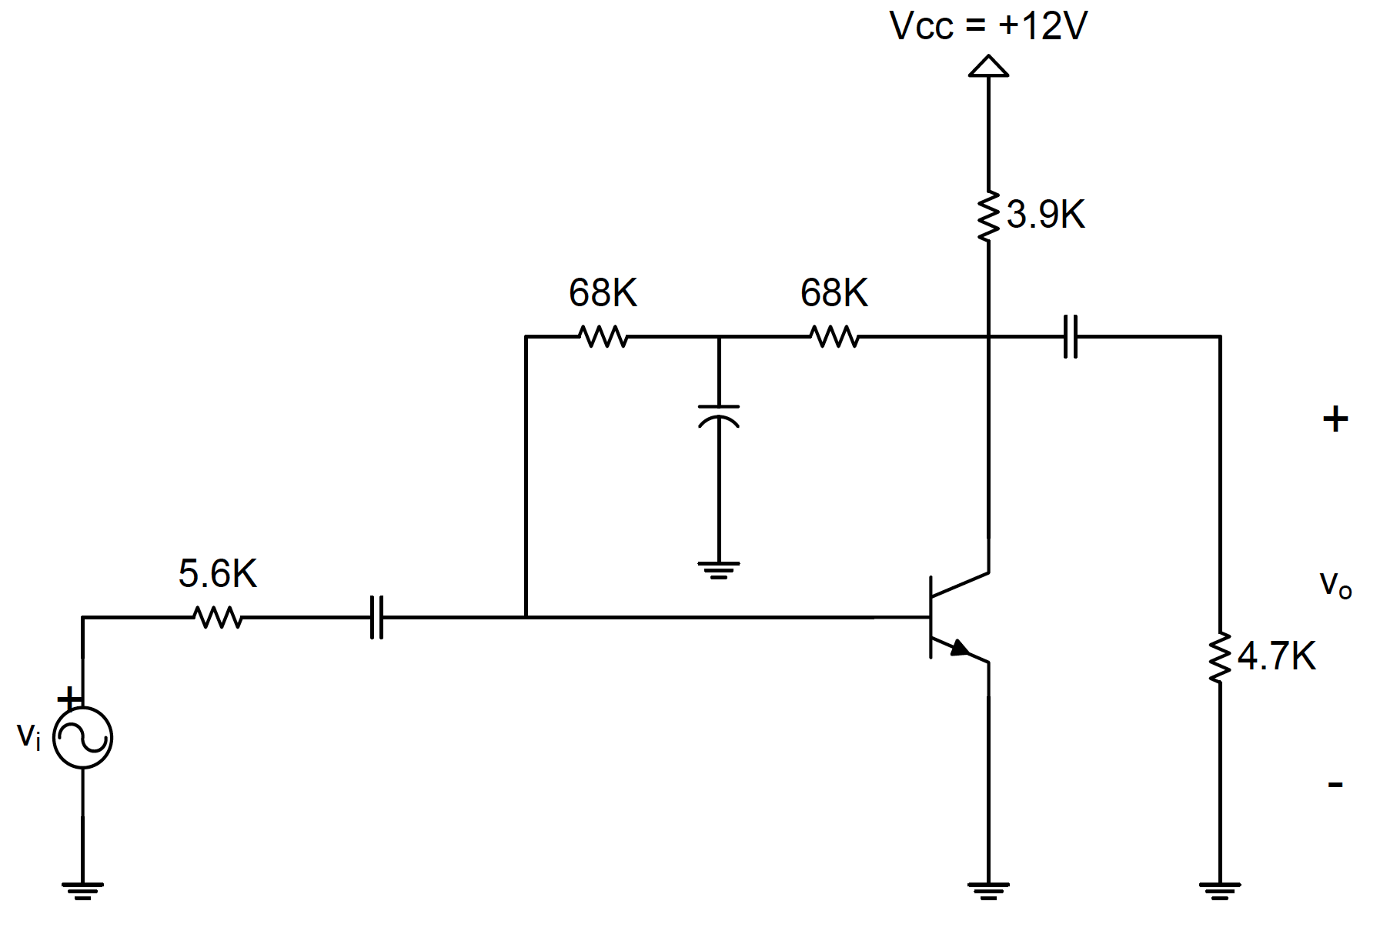
Figure 2

